**Power BI Dashboard**

**Project: US Regional Sales Data**

**By: Prathamesh Petkar**

**Key Performance Indicators (KPIs)**

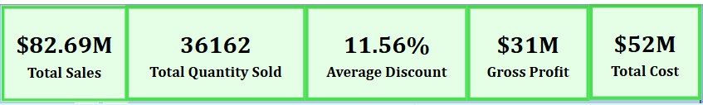

**💰 Total Sales: $82.69M**

* The company generated a strong revenue of $82.69 million, showcasing solid market penetration across multiple channels.
* This figure reflects not only effective sales execution but also a healthy demand environment, possibly supported by seasonal or promotional strategies.
* When compared with gross profit, it suggests a relatively balanced pricing model with margin-preserving strategies.

**📦 Total Quantity Sold: 36,162 Units**

* Over 36K units sold indicates robust volume throughput across the product portfolio.
* When cross-referenced with volume distribution by channel, we notice significant skew toward Online and In-Store, pointing to channel preferences in consumer buying behavior.
* It also highlights effective inventory management and demand planning at a macro level.

**🏷️ Average Discount: 11.56%**

* An average discount rate of 11.56% suggests a moderately promotional pricing approach.
* It’s not overly aggressive, implying that products may be positioned with value perception rather than deep discounting.
* This discount rate seems sufficient to stimulate conversion without critically eroding margins.

**💹 Gross Profit: $31M**

* A gross profit of $31 million means the business retains approximately 37.5% of its total revenue after covering direct costs.
* This is a solid margin level in a multi-channel retail setup, especially when operating both physical and digital channels.
* It also reflects well on the pricing strategy and possibly volume-driven margin leverage in high-performing channels.

**💸 Total Cost: $52M**

* Total costs accounting for $52 million represent the largest portion of sales absorbed by operational and supply-side expenses.
* The relative cost level is reasonable given the gross profit retained, but it indicates there is room for tightening channel-specific efficiencies.
* Cost distribution across channels (seen in profitability analysis) varies, pointing to opportunities in channel-specific optimization.

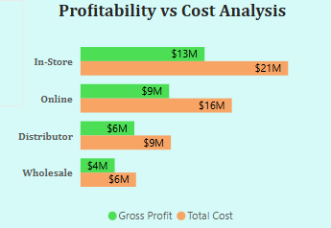**Profitability vs Cost Analysis**

**Inference**

**In-Store**

* **Sales: $34M | Cost: $21M | Gross Profit: $13M**
* In-Store is the **largest revenue-generating channel**, contributing over **40%** of total sales.
* It also incurs the **highest operational costs**, yet maintains the **highest gross profit in absolute terms**, indicating the benefit of volume-based sales.
* The margin isn't proportionally higher, which suggests that **costs scale with revenue** possibly due to retail expenses such as staffing, space, and overhead.

**Online**

* **Sales: $25M | Cost: $16M | Gross Profit: $9M**
* Online is the **second highest in both revenue and profit**, but more importantly, it shows a **better cost-to-sales ratio** than In-Store.
* Despite lower revenue than In-Store, it achieves **comparable profitability per dollar of cost**, pointing to **high operational efficiency**.
* Likely benefits from **lower infrastructure costs** and **better discount targeting**, potentially through digital campaigns.

**Distributor**

* **Sales: $15M | Cost: $11M | Gross Profit: $4M**
* The Distributor channel shows a **noticeably thinner margin**, with costs consuming **nearly three-fourths** of revenue.
* May be impacted by **fixed partner pricing**, **distribution fees**, or **limited control over downstream pricing**.
* Sales are moderate, but profit yield is relatively weak compared to Online or In-Store.

**Wholesale**

* **Sales: $9M | Cost: $6.2M | Gross Profit: $2.8M**
* The smallest contributor across all metrics.
* While cost appears manageable, the overall profit is low, and its **sales volume is underwhelming**.
* This could indicate a **low engagement customer base**, limited market coverage, or poor competitive positioning.

**Implications**

1. **Maximize Efficiency in In-Store Channel**

* In-Store performs well in terms of total revenue and profit, but costs are high. There's an opportunity to **improve efficiency** through:
  + Lean store operations,
  + Optimizing staffing levels,
  + Negotiating better lease/vendor terms,
  + Or selectively pushing high-margin products in-store.

1. **Scale the Online Channel**

* Online strikes an ideal balance between **revenue and efficiency**.
* It should be a **priority for marketing and promotional investments**, as it is capable of scaling further without major cost inflation.
* Enhance personalization, loyalty programs, and cross-selling online.

1. **Reevaluate the Distributor Model**

* With high-cost absorption and flat profits, it's essential to **review contract terms** or **restructure how partners are incentivized**.
* Introducing **performance-based pricing, shared margin structures**, or targeted training/support could improve partner productivity and margins.

1. **Decide the Role of Wholesale**

* Wholesale, as the lowest performer, requires a strategic decision:
  + **Revamp with aggressive pricing** or volume incentives to make it competitive,
  + Or **reduce focus** and allocate resources to more profitable channels.
  + If retained, explore bundling or exclusive B2B deals to lift its contribution.

1. **Align Costs with Value Delivered**

* Across all channels, profits are positive, but optimizing the **cost structure per channel** could significantly lift overall margin.
* Benchmark operational KPIs and develop **channel-specific margin targets**.

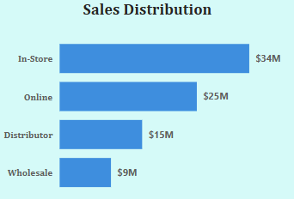**Sales Distribution by Channel**

This **horizontal bar chart** visualizes each channel's contribution to total sales in percentage terms giving a proportional view of where the revenue is coming from across **In-Store, Online, Distributor, and Wholesale** segments.

**Inference**

**In-Store – 41% of Total Sales**

* The **dominant revenue generator**, contributing **nearly half** of the total company revenue.
* Indicates a **strong physical retail footprint**, likely driven by customer loyalty, store accessibility, or experiential shopping advantages.
* This channel likely benefits from **higher ticket-size purchases** rather than sheer volume (as seen in earlier visuals).

**Online – 30% of Total Sales**

* A **strong second**, Online contributes almost a **third of total revenue**.
* Suggests that the business has made significant inroads in digital sales, possibly supported by effective digital marketing, a user-friendly platform, or strategic promotions.
* This high share also implies growing customer confidence in online transactions and possibly wider geographic reach.

**Distributor – 18% of Total Sales**

* The Distributor channel holds a **moderate revenue share**, but falls short compared to In-Store and Online.
* Reflects **indirect channel reliance** — possibly B2B or third-party resellers.
* Revenue here might be constrained by **fixed pricing arrangements**, lower sales frequency, or dependency on partner performance.

**Wholesale – 11% of Total Sales**

* The **lowest performing** channel in terms of revenue.
* While it still adds to the overall revenue pie, its marginal share may point to **limited market coverage**, **low customer stickiness**, or **minimal brand control** in wholesale environments.

**Implications**

1. **Prioritize Investment in In-Store and Online Channels**
   * These two channels account for **over 70% of total sales**.
   * Focus marketing budgets, customer experience enhancements, and innovation in these channels to **amplify what's already working**.
   * Test omnichannel strategies that **blend Online and In-Store journeys** (e.g., Buy Online, Pick Up In-Store).
2. **Optimize the Distributor Channel**
   * With 18% of sales, Distributor is a significant mid-tier channel. However, the business should **revisit channel incentives, pricing flexibility**, or **training programs** to lift its productivity.
   * Explore **partner segmentation** to focus on top-performing resellers.
3. **Reevaluate the Role of Wholesale**
   * At 11%, Wholesale has a minor revenue footprint. Decide whether to:
     + **Scale it** via volume deals, bundling, or private-label options,
     + Or **streamline focus** on the other more profitable, scalable channels.
   * Could serve niche market segments or act as a **testing ground** for products.
4. **Channel-Specific Messaging**
   * The nature of each channel differs — tailor promotions and messaging accordingly.
     + **In-Store**: Emphasize exclusivity, tactile experiences, or loyalty.
     + **Online**: Highlight convenience, customization, and fast shipping.
     + **Distributor/Wholesale**: Position volume value, reliability, and service support.

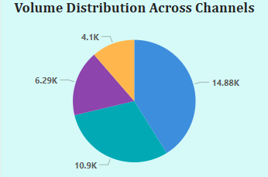**Volume Distribution Across Channels**

This **pie chart** shows the number of units sold per channel, giving a view of where most of the **sales volume (quantity)** is coming from which adds another dimension beyond just revenue share. This contrast helps understand pricing dynamics and product mix strategies by channel.

**Inference**

**Online – 14,881 Units (41%)**

* The **highest volume channel**, responsible for **over 40%** of all units sold.
* This suggests the **Online channel focuses on high-velocity, possibly lower-priced items**, or utilizes more aggressive promotions that drive unit sales.
* Indicates a **price-sensitive or promotion-driven buyer base**, likely making frequent but lower-value purchases.

**In-Store – 10,903 Units (30%)**

* Though In-Store drives the highest **revenue share**, it accounts for **30% of units sold**.
* This points toward a **higher average price per unit**, likely due to premium purchases or upselling effectiveness in a physical environment.
* Customers may value physical product interaction, convenience, or personalized service, contributing to **higher-value transactions** despite slightly lower volume.

**Distributor – 6,292 Units (17%)**

* Distributor contributes a **moderate share of volume**, similar to its revenue share.
* Implies **steady but controlled movement of goods**, possibly through bulk orders or fixed purchase cycles.
* Pricing may be consistent due to pre-agreed contracts, limiting flexibility but maintaining stable volumes.

**Wholesale – 4,086 Units (11%)**

* The **lowest unit contributor**, mirroring its revenue performance.
* Could reflect limited market coverage, smaller bulk orders, or less competitive pricing for end buyers.
* This may also indicate a **non-priority channel** in terms of marketing and product focus.

**Strategic Implications**

1. **Strengthen Margin Controls for Online Channel**
   * With highest volume but lower price per unit, Online sales could risk thinning margins.
   * Implement strategies such as bundled pricing, loyalty programs, or tiered delivery services to enhance profitability while maintaining volume.
2. **Leverage In-Store for High-Value Conversions**
   * The lower unit volume but higher revenue in In-Store suggests a premium channel.
   * Maximize this by emphasizing personalized service, exclusive products, or in-store-only promotions.
   * Could also use it as a channel to launch or test premium SKUs.
3. **Review Distributor Strategy for Growth or Efficiency**

* Since Distributor balances both revenue and volume in the mid-range, consider optimizing it through:
  + **Partner enablement**,
  + **Volume-based discounts**, or
  + **Localized stock management**.

1. **Revitalize or Refocus Wholesale**

* Wholesale is underperforming in both revenue and volume.
* Decision point: Scale it with better partner terms, product-mix reconfiguration, or targeted campaigns — or deprioritize if ROI remains poor.

1. **Align Product-Mix with Channel Strengths**

* Push fast-moving SKUs through Online, premium products through In-Store, and consider volume-efficient items for Distributor and Wholesale.
* Use this data to improve inventory placement and forecasting accuracy across locations.

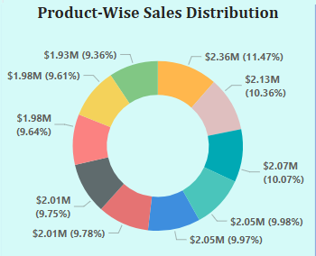**Product-Wise Sales Distribution (Top 10 Products)**

This **donut chart** breaks down total sales among the top 10 product SKUs (identified by IDs), highlighting how revenue is spread across the company’s best-performing products.

**Inference**

**🔸 Evenly Spread Revenue Share**

* The top 10 products each contribute between ~8% and ~11% of total sales, with the top product reaching around 11.47%, and the others closely clustered.
* This reflects a well-balanced product portfolio among top-performing SKUs — no single product dominates the revenue stream.

**🔸 Absence of Sales Dependency on One SKU**

* The relatively flat distribution indicates the company is not overly reliant on a single blockbuster product, which is good for revenue stability and lowers business risk.
* A diversified top-10 suggests broad customer demand across multiple SKUs, hinting at strong overall product-market fit.

**🔸 Sales Consistency Across Multiple Products**

* The closeness in contribution suggests that multiple products are performing consistently well, indicating effective merchandising, inventory availability, and channel exposure.
* It could also mean that pricing and positioning are working effectively across different categories.

**Implications**

1. **Promote Top-Performing Products for Greater Uplift**

* While distribution is balanced, the top 3 SKUs still account for over 30% of top-tier revenue — this makes them strong candidates for:
  + Hero product marketing campaigns,
  + Cross-sell opportunities, or
  + Channel spotlighting (e.g., homepage banners, retail endcaps).

1. **Explore Potential of Next-Tier Products**
   * The even spread indicates no SKU has yet "broken out" as a market leader.
   * Evaluate if some of these products can be elevated with strategic pricing, bundling, or seasonal offers to increase their share.
2. **Mitigate Inventory Risks Across SKUs**
   * A broad base of contributors requires tight inventory planning and demand forecasting to avoid overstocking or understocking across channels.
3. **Use Data to Refine Product Strategy**
   * Since the top 10 products all perform within a close sales range, conduct deeper SKU-level analysis to identify:
     + Margin performance,
     + Repeat purchase rates, and
     + Channel-specific success.
   * Use this to refine product expansion, packaging updates, or R&D investments.
4. **Future Product Design and Assortment Planning**
   * Learn from these successful products in terms of features, pricing, placement, or target segment, and apply those insights when:
     + Launching new products,
     + Refreshing low-performing SKUs, or
     + Creating seasonal collections.

**Year-over-Year Sales Performance (Quarterly Trend)**

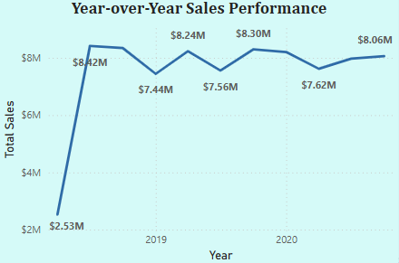

**Inference**

**2018 (Partial Year – Q2 to Q4)**

* **Q2 – $2.53M**: The year began modestly with a relatively low Q2 performance, likely reflecting a business still in early growth or market penetration phase.
* **Q3 – $8.42M**: Huge spike in Q3, more than **tripling Q2 sales** — potentially due to expansion in channels, new product introductions, or promotional success.
* **Q4 – $8.35M**: Minor dip from Q3 but still sustained — suggests the business **locked in growth momentum** and continued strong execution through the holiday season.

**Insight**: Late 2018 marked the start of a high-growth phase, particularly in Q3–Q4, setting the baseline for future years.

**2019 (Full Year)**

* **Q1 – $7.44M**: Slight drop from the 2018 holiday season but still significantly higher than 2018’s Q2 — stable transition into the new year.
* **Q2 – $8.24M**: Sales picked up again, nearing 2018's Q3 peak, possibly due to summer campaigns or fiscal planning cycles.
* **Q3 – $7.56M**: Slight dip in Q3, unlike the previous year’s Q3 surge — could suggest a **loss of momentum** or weaker seasonal push.
* **Q4 – $8.30M**: Recovery in Q4, closely matching the prior year’s performance. This suggests **strong holiday season strategy** but also **flat year-over-year growth**.

**Insight**: 2019 showed **stabilization rather than aggressive growth**, indicating either market saturation or less impactful differentiation compared to 2018.

**2020 (Full Year)**

* **Q1 – $8.21M**: Strong start, better than 2019 Q1 — possibly reflects **repeat customers or solidified market presence**.
* **Q2 – $7.62M**: Drop from Q1; this could be due to **external disruptions (e.g., COVID-19 onset)** affecting retail activity or supply chains.
* **Q3 – $7.97M**: Mild rebound, signaling **adaptation to new operating norms**.
* **Q4 – $8.10M**: Slight dip from prior years’ Q4 but still healthy — shows that the **business managed to maintain stability** even in uncertain times.

**Insight**: 2020 was a year of **resilience and stabilization**, with minor quarterly fluctuations but overall steadiness — possibly driven by operational agility.

**Performance Summary Table**

| **Quarter** | **2018** | **2019** | **2020** |
| --- | --- | --- | --- |
| Q1 | – | $7.44M | $8.21M |
| Q2 | $2.53M | $8.24M | $7.62M |
| Q3 | $8.42M | $7.56M | $7.97M |
| Q4 | $8.35M | $8.30M | $8.10M |

**Implications**

1. **Target Q2 for Growth Initiatives**

* Q2 in both 2019 and 2020 showed fluctuations — consider aggressive Q2 campaigns, mid-year product refreshes, or strategic partnerships to reinforce momentum during this quarter.

1. **Strengthen Q3 Execution**

* Compared to 2018, Q3 in 2019 and 2020 slightly underperformed.
* Re-evaluate Q3 activities — look into improving back-to-school promotions, inventory cycles, or demand planning to restore peak Q3 performance.

1. **Capitalize on Consistent Q4 Strength**

* Q4 has been consistently strong across all three years — leverage this by increasing marketing spends, launching holiday bundles, and ensuring supply chain readiness.

1. **Maintain Flexibility for External Disruptions**

* The dip in Q2 2020 highlights the need for business continuity planning and agile response systems (e.g., rapid channel shifts, contingency stocks).

1. **Break Out of Growth Plateau**

* Since **sales have plateaued between $7.4M–$8.4M per quarter since late 2018**, new growth levers are needed:
  + **Regional expansion**,
  + **Higher-ticket product launches**, or
  + **New channel diversification** (e.g., subscription-based models).

**Discount Effectiveness Analysis**

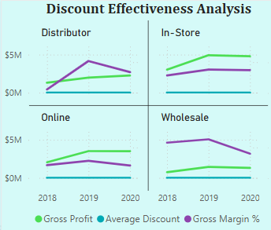

**Inference – Channel by Channel**

**In-Store Channel**

* **Discount Trend:** Discounts gradually increased over 3 years, likely to maintain footfall or compete with online prices.
* **Gross Profit:** Stayed relatively stable despite higher discounts — implying volume gains offset discount losses.
* **Gross Margin %:** Only a mild decline, suggesting discounts didn’t deeply erode profitability.

**Insight**: In-store customers are possibly less price-sensitive, or the experience value justifies margin retention. Also indicates efficient store-level operations or loyal customer base.

**Online Channel**

* **Discount Trend**: Noticeable rise in average discounts year-on-year — possibly due to increasing online competition or aggressive campaigns.
* **Gross Profit**: Also increased steadily, which means discounting worked well to drive both volume and value.
* **Gross Margin %**: Slight drop, but the profit growth compensates for it.

**Insight**: Online channel is highly responsive to discount-led promotions. It delivers both scale and margin when managed well — a strong candidate for performance marketing investments.

**Distributor Channel**

* **Discount Trend**: Fairly flat over the years, with minimal changes.
* **Gross Profit**: Plateaued — discounts did not translate into better performance.
* **Gross Margin %**: Remained static or slightly down, showing inefficiency in current pricing models.

**Insight**: Current discounting here is ineffective. Suggests distributor partners may not pass on discounts to end customers or demand may be contractually fixed, offering limited flexibility.

**Wholesale Channel**

* **Discount Trend**: Conservative discounting strategy with low and steady levels.
* **Gross Profit**: Gradual improvement despite minimal discounting.
* **Gross Margin %**: Also improved slightly — indicating the channel has potential for volume growth even without discounts.

**Insight**: Wholesale buyers are likely value-focused or loyal, suggesting opportunity to stimulate sales with minimal discount interventions.

**Implications**

1. **Amplify Online Discount Campaigns**

* Online shows the **best ROI on discounting**, so continue smart promotions (e.g., limited-time offers, bundle discounts) to scale further.

1. **Maintain Discount Balance In-Store**

* In-store performance is **stable with controlled discounting**. Continue using **tactical offers** (e.g., loyalty rewards, event-based markdowns) rather than flat discounts.

1. **Re-engineer Distributor Channel**

* Reassess how discounts are being utilized — consider **performance-linked incentives**, **rebates**, or restructuring contracts to better align with actual sell-through rates.

1. **Unlock Wholesale Growth with Targeted Promotions**
   * Even modest discounts may push wholesale sales higher. Test **tiered discounts** or **bulk purchase bonuses** to stimulate larger orders without margin damage.